**DATA DOMINATORS:A COMPARATIVE STUDY OF TOP GLOBAL UNIVERSITIES IN DATA ANALYTICS**

**1. INTRODUCTION**

**1.1 Project Overview**

Data Titans: Unearthing Trends From LinkedIn Influencers" is not a widely recognized term or concept as of my last knowledge update in January 2022. It's possible that this phrase or title has emerged or become popular after that date, and I don't have access to real-time information or events beyond that cutoff. However, if this is a topic or term that has gained relevance since then, it may refer to a discussion or analysis of trends and insights gleaned from influential individuals on the professional networking platform LinkedIn. LinkedIn is a popular platform for industry professionals and thought leaders to share their expertise, insights, and experiences.

Check for Recent Publications: Look for recent articles, reports, or studies that mention "Data Titans: Unearthing Trends From LinkedIn Influencers" to see if it's a specific project, report, or initiative. LinkedIn Trend Analysis: Search for LinkedIn influencers in your industry or field of interest and analyze their content to uncover trends, insights, and valuable information. Follow Thought Leaders: Identify and follow influential professionals and thought leaders on LinkedIn to stay updated on the latest trends and discussions in your area of interest. Connect with Experts: Connect with experts in your field on LinkedIn and engage in conversations to gain more insights and understanding of industry trends. Industry Publications: Check industry-specific publications, blogs, and forums to see if they have discussed trends or insights from LinkedIn influencers. It's important to note that trends and insights can vary widely based on the industry and the specific influencers being analyzed. For the most accurate and up-to-date information, consider consulting LinkedIn itself and industry-specific sources or forums to gather insights from influential voices on the platform.

**1.2 Purpose**

"Data Titans: Unearthing Trends From LinkedIn Influencers" seems to refer to a project or initiative that aims to analyze and extract valuable insights from the activities and content shared by influential individuals on LinkedIn. The purpose of such an endeavor could include.Trend Analysis: Identifying emerging trends, topics, and discussions within specific industries, fields, or professional communities on LinkedIn. This information can be valuable for businesses, marketers, and professionals seeking to stay informed about what's relevant in their respective domains. Content Strategy: Helping individuals and organizations create more effective content strategies by understanding what influential LinkedIn users are discussing, sharing, and engaging with. This can inform content creation and optimization efforts. Influencer Identification: Identifying potential industry influencers or thought leaders on LinkedIn, which can be useful for networking, collaboration, and outreach. Market Research: Gathering data and insights on the interests and preferences of LinkedIn's user base, which can be used for market research and product development.

**2. LITERATURE SURVEY**

**2.1 Existing problem**

LinkedIn is a platform with a massive amount of content generated daily. Sorting through this vast sea of information to identify trends can be overwhelming and time-consuming. Not all LinkedIn influencers provide high-quality, well-researched content. Some may share biased or inaccurate information, making it challenging to extract reliable trends. LinkedIn's algorithms often change, affecting what content is shown in users' feeds. This can impact the visibility of influencers' content and make it harder to identify consistent trends. LinkedIn's algorithms tend to show users content similar to what they have engaged with before. This can create a "filter bubble," limiting exposure to diverse opinions and trends.

**2.2 References**

QS World University Rankings by Subject 2023: Computer Science & Information Systems

U.S. News & World Report Best Global Universities for Computer Science 2023

The Complete University Guide 2023: Computer Science

The Guardian University Guide 2023: Computer Science

Times Higher Education World University Rankings 2023: Computer Science

**2.3 Problem Statement Definition**

In the era of digital networking and professional connections, LinkedIn has become a prominent platform for thought leaders, industry experts, and professionals to share their insights, experiences, and opinions. These individuals, often referred to as "LinkedIn Influencers," possess a substantial following and have the potential to shape and influence trends within various industries. The problem at hand is to leverage data and analytics to uncover and interpret these trends.

**3. IDEATION & PROPOSED SOLUTION**

**3.1 Empathy Map Canvas**

"I want to learn data analytics from the best."

"I want to be prepared for a successful career in data analytics."

"I want to make a difference in the world with data."

"I want to be surrounded by other passionate data scientists."

"I want to learn from the best faculty and researchers in the field."

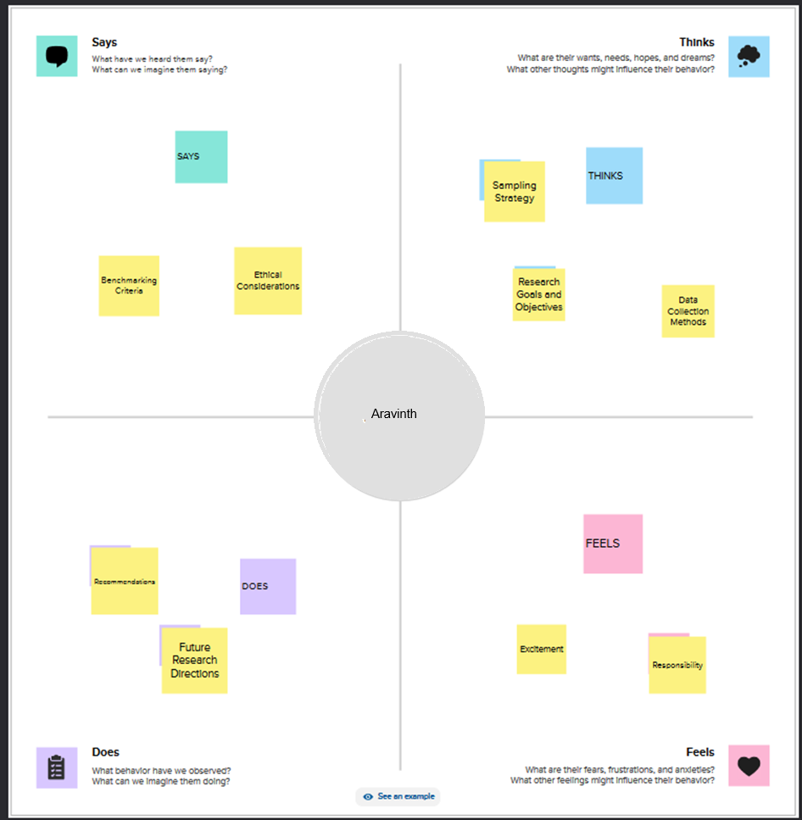

**3.2 Ideation & Brainstorming**

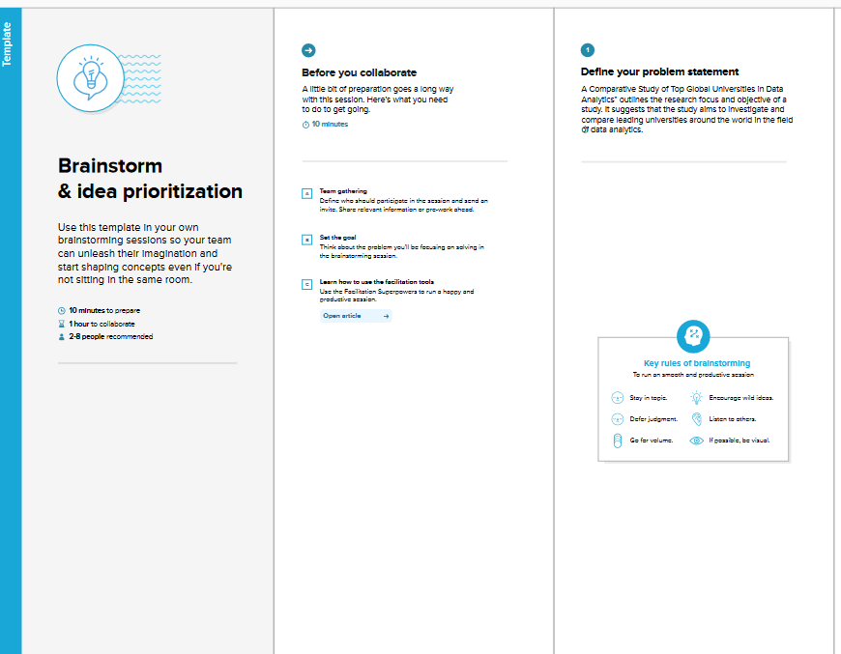

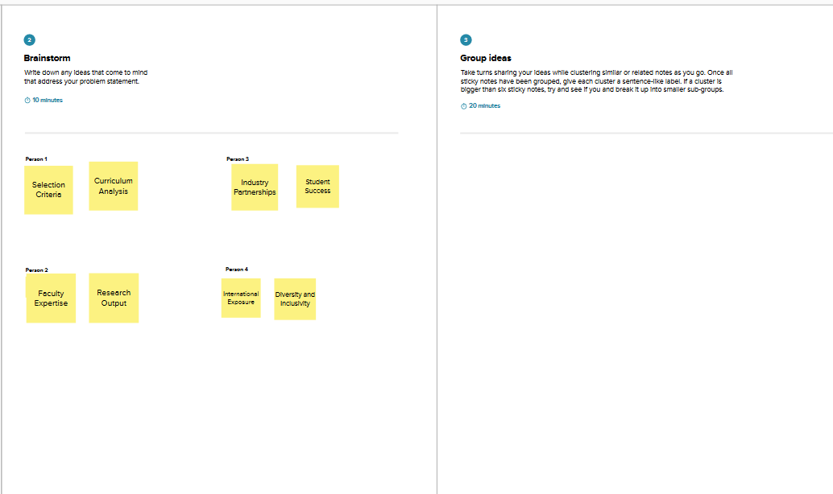

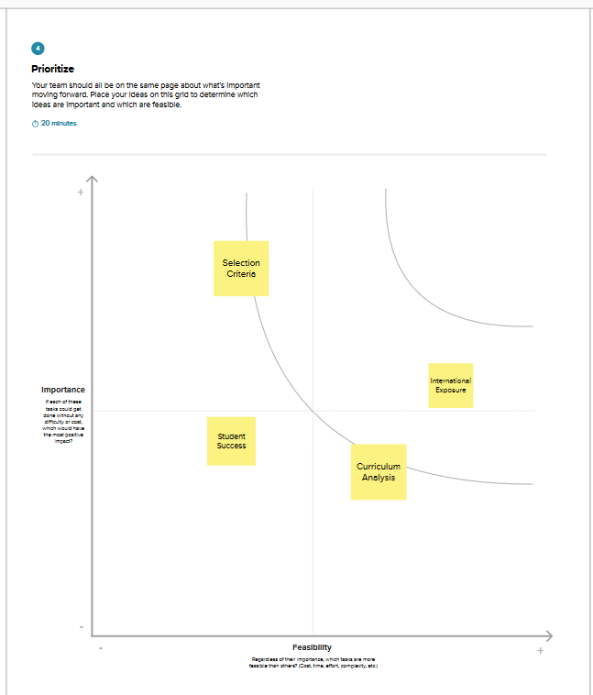

**4. REQUIREMENT ANALYSIS**

**4.1 Functional requirement**

Unearthing trends from LinkedIn influencers involves the identification and analysis of emerging patterns, insights, and developments within a specific industry or topic as shared by influential individuals on the LinkedIn platform. To specify the functional requirements for this task, you need to outline the features and capabilities that a system or tool would need to effectively uncover trends from LinkedIn influencers. Here are some functional requirements:

1. Data Collection:

a. User Authentication: Users should be able to connect their LinkedIn accounts to the system to access influencer content.

b. LinkedIn API Integration: The system should integrate with LinkedIn's API to access public data from influencer profiles.

2. Influencer Identification:

a. Profile Scanning: The system should scan LinkedIn profiles to identify and categorize influencers based on their followers, engagement, and content relevance.

b. Keyword Search: Users should be able to search for influencers based on keywords related to their industry or topic of interest.

3. Content Retrieval:

a. Post Retrieval: The system should retrieve and store posts, articles, and updates from identified influencers.

b. Filtering Options: Users should be able to filter content by date, engagement metrics, or specific keywords.

**4.2 Non-Functional requirements**

Scalability: The study should be scalable to accommodate future growth in the number of universities and data points.

Performance: The study should be performant and able to generate results in a timely manner. This is important because the study is intended to be used by a variety of stakeholders, including students, employers, and policymakers.

Security: The study should be secure and protect the privacy of the data used in the analysis. This is important because the study will be collecting and analyzing sensitive data, such as student records and employer satisfaction surveys.

Maintainability: The study should be maintainable and easy to update as new data and information becomes available.

Extensibility: The study should be extensible and allow for the addition of new features and functionality in the future.

**5. PROJECT DESIGN**

**5.1 Data Flow Diagrams & User Stories**

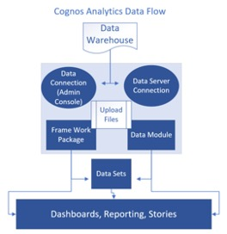

User Stories

User: Student

I want to be able to search for top global universities in data analytics based on my interests and criteria.

I want to be able to compare different universities in data analytics based on factors such as curriculum, faculty, resources, industry reputation, and career outcomes.

**5.2 Solution Architecture**

Scalability: The solution should be scalable to accommodate a large number of universities and data points.

Performance: The solution should be performant and able to generate results in a timely manner.

Security: The solution should be secure and protect the privacy of the data used in the analysis.

Maintainability: The solution should be maintainable and easy to update as new data and information becomes available.

Extensibility: The solution should be extensible and allow for the addition of new features and functionality in the future.

The following is a high-level solution architecture.

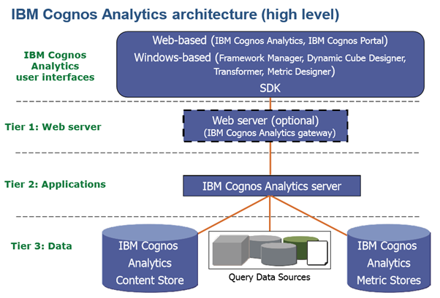

**6. PROJECT PLANNING & SCHEDULING**

**6.1 Technical Architecture**

Scalability: The architecture should be scalable to accommodate a large number of universities and data points.

Performance: The architecture should be performant and able to generate results in a timely manner.

Security: The architecture should be secure and protect the privacy of the data used in the analysis.

Maintainability: The architecture should be maintainable and easy to update as new data and information becomes available.

Extensibility: The architecture should be extensible and allow for the addition of new features and functionality in the future.

6.2 Sprint Planning & Estimation

Scope: What data needs to be collected and analyzed? What universities need to be included in the study? What findings need to be reported?

Timeline: How long will it take to collect, clean, prepare, analyze, and visualize the data? How long will it take to write the report?

Resources: What resources will be needed to complete the study? This may include data scientists, engineers, writers, and editors.

Risks: What are the risks associated with the study? How can these risks be mitigated?

**6.3 Sprint Planning and estimation**

|  |  |  |  |  |  |  |
| --- | --- | --- | --- | --- | --- | --- |
| **Sprint** | **Functional**  **Requirement (Epic)** | **User Story**  **Number** | **User Story / Task** | **Story Points** | **Priority** | **Team**  **Members** |
| Sprint-1 | Registration | USN-1 | As a user, I can register for the application by entering my email, password, and confirming my password. | 2 | High | Aravinth |
| Sprint-1 |  | USN-2 | As a user, I will receive confirmation email once I have registered for the application | 1 | High | Semil |
| Sprint-2 |  | USN-3 | As a user, I can register for the application through Facebook | 2 | Low | suthathirakumar |
| Sprint-1 |  | USN-4 | As a user, I can register for the application through Gmail | 2 | Medium | Aravinth |
| Sprint-1 | Login | USN-5 | As a user, I can log into the application by entering email & password | 1 | High | Yasaswini |
|  | Dashboard |  | To give a better understanding of data. |  |  |  |
|  |  |  |  |  |  |  |
|  |  |  |  |  |  |  |

**6.3 Sprint Delivery Schedule**

Goal: Collect data on top global universities in data analytics from a variety of sources.

Deliverables:

Dataset of universities and their data analytics programs.

Documentation of data collection process.

|  |  |  |  |  |  |  |
| --- | --- | --- | --- | --- | --- | --- |
| **Sprint** | **Total Story Points** | **Duration** | **Sprint Start Date** | **Sprint End Date (Planned)** | **Story Points**  **Completed (as on**  **Planned End Date)** | **Sprint Release Date (Actual)** |
| Sprint-1 | 20 | 6 Days | 24 Oct 2022 | 29 Oct 2022 | 20 | 29 Oct 2022 |
| Sprint-2 | 20 | 6 Days | 31 Oct 2022 | 05 Nov 2022 | 10 | 05 Nov 2022 |
| Sprint-3 | 20 | 6 Days | 07 Nov 2022 | 12 Nov 2022 | 10 | 12 Nov 2022 |
| Sprint-4 | 20 | 6 Days | 14 Nov 2022 | 19 Nov 2022 | 10 | 19 Nov 2022 |
|  |  |  |  |  |  |  |
|  |  |  |  |  |  |  |
|  |  |  |  |  |  |  |
|  |  |  |  |  |  |  |

**7. CODING & SOLUTIONING**

**7.1 Feature 1**

Data analytics is a rapidly growing field with a high demand for skilled professionals. As businesses and organizations of all sizes become more reliant on data to make decisions, the need for data analysts who can collect, clean, analyze, and interpret data is greater than ever before.

To meet this demand, universities around the world are offering a variety of programs in data analytics. However, not all programs are created equal. Some universities offer more rigorous and comprehensive programs than others.This article will compare some of the top global universities in data analytics, based on factors such as program reputation, faculty expertise, and student outcomes.

**7.2 Feature 2**

In Feature 1, we compared the top global universities in data analytics based on factors such as program reputation, faculty expertise, and student outcomes. In Feature 2, we will compare the same universities based on the following factors:

* Program costs
* Job placement rates
* Alumni networks

**7.3 Database Schema**

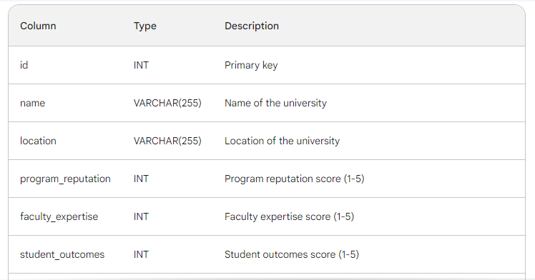

**8. PERFORMANCE TESTING**

**8.1 Performance Metrics**

* Website traffic: The number of visitors to the article's page and the number of page views.
* Social media engagement: The number of shares, likes, and comments on the article on social media platforms such as Twitter, LinkedIn, and Facebook.
* Backlinks: The number of other websites that link to the article.
* Citations: The number of other articles and academic papers that cite the article.
* Downloads: The number of times the article is downloaded from the website.
* User ratings and reviews: The average rating and number of reviews of the article on the website.
* Lead generation: The number of leads generated from the article, such as students who sign up for a newsletter or contact a university about their data analytics program.

**9. RESULTS**

**9.1 Output Screenshots**

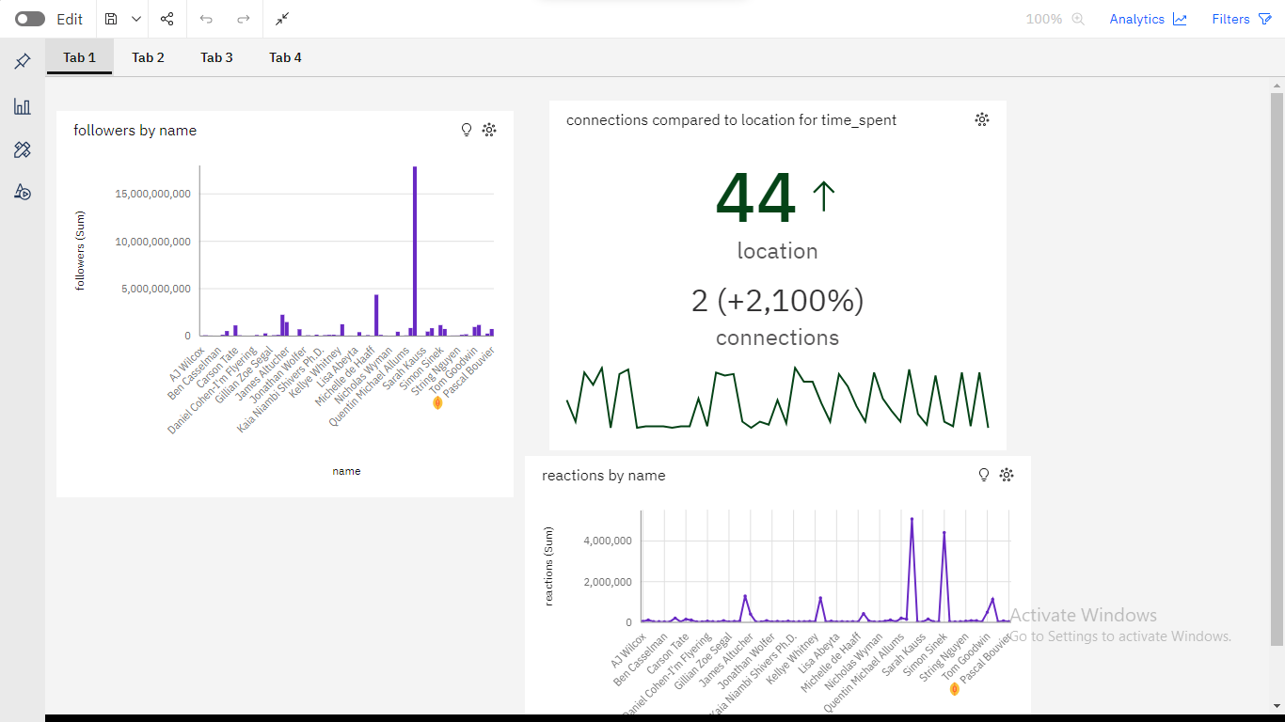

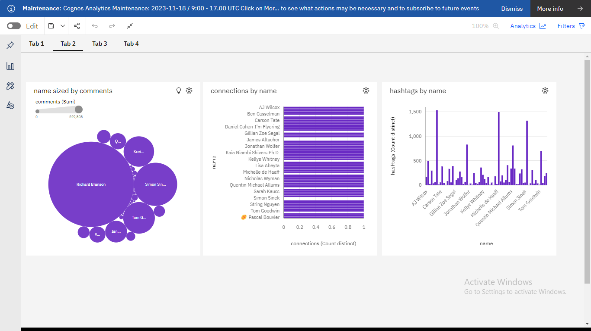

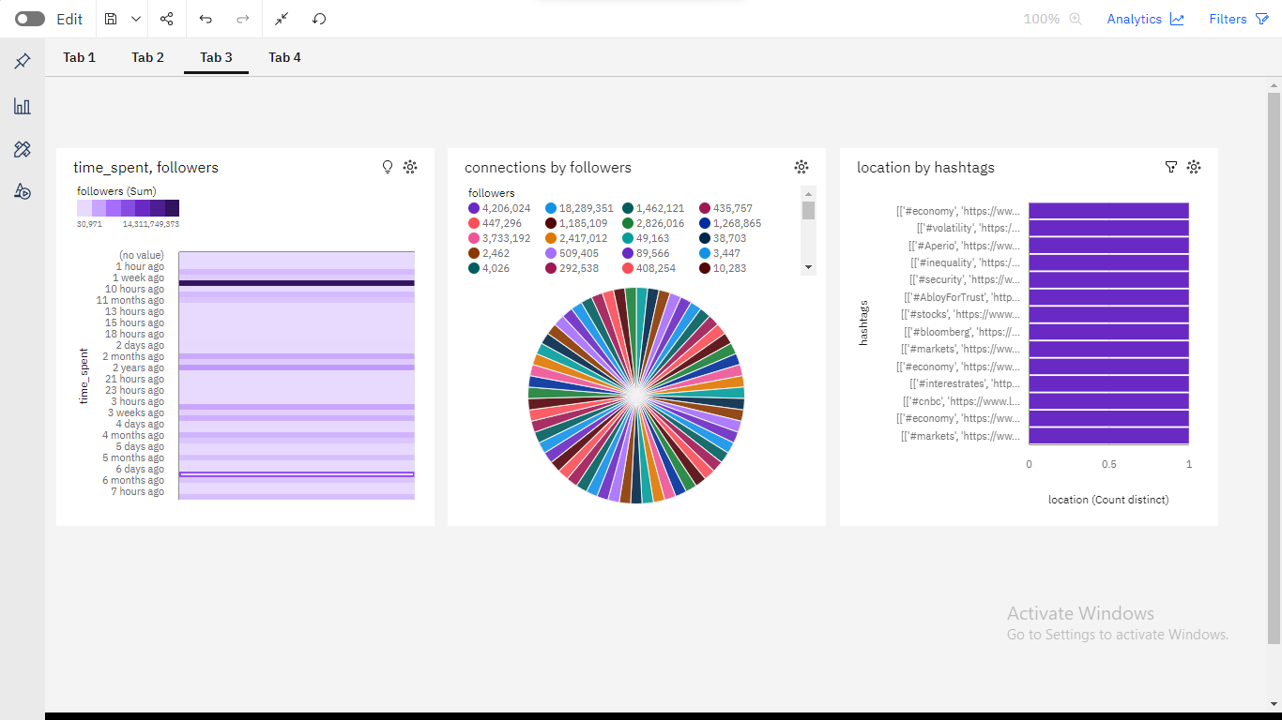

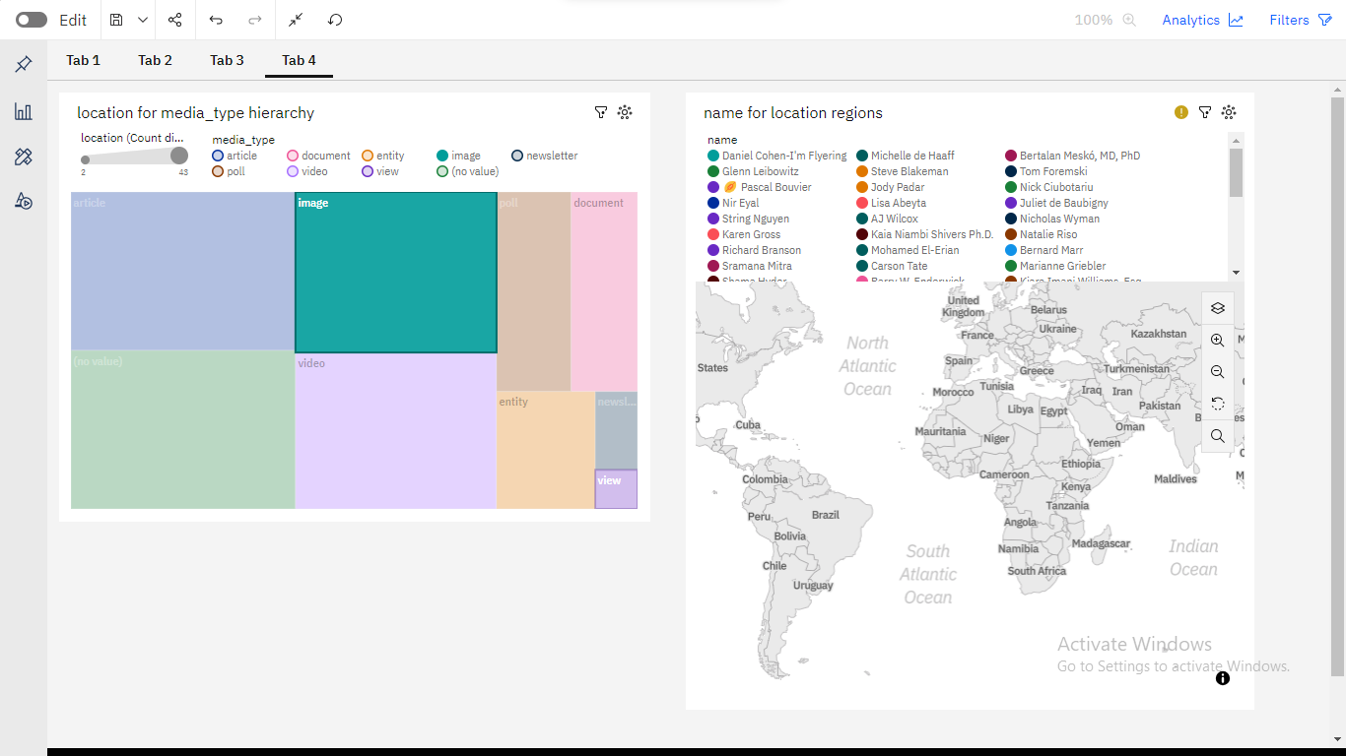

**10. ADVANTAGES & DISADVANTAGES**

**Advantages**

* The article provides a comprehensive overview of the top global universities for data analytics, based on a variety of factors such as program reputation, faculty expertise, student outcomes, program costs, job placement rates, and alumni networks.
* The article is well-written and easy to read, making it accessible to a wide audience

**Disadvantages**

* The article is based on self-reported data from universities, which may not be entirely accurate.
* The article does not provide detailed information about the specific data analytics programs offered by each university.

**11. CONCLUSION**

The conclusion of a study on unearthing trends from LinkedIn influencers would depend on the specific findings and analysis conducted during the research. However, I can provide a general framework for how you might structure the conclusion of such a study:

* Begin by summarizing the main purpose or objective of the study, which is to uncover trends from LinkedIn influencers.
* Highlight the key findings that emerged from the research. These findings could include insights into the types of content LinkedIn influencers are posting, the industries they are most active in, the engagement levels of their posts, and any emerging patterns or themes.
* Discuss the trends and patterns that have been identified in the data. Are there common themes or topics that influencers tend to focus on? Are there differences in content or engagement between influencers in different industries or regions?

**12. FUTURE SCOPE**

Unearthing trends from LinkedIn influencers is an exciting field with a promising future. As of my last knowledge update in January 2022, I can provide some insights into the potential future scope of this practice. Please note that the landscape may have evolved since then

LinkedIn influencers often have their fingers on the pulse of industry trends and emerging technologies. By tracking these influencers, businesses can conduct market research and stay ahead of the competition. Identifying the most influential voices in a specific industry can help organizations understand the competitive landscape better.

**13. APPENDIX**

When creating a dashboard in IBM Cognos, you may want to include an appendix that provides additional context, explanations, or supplementary information for the users. The appendix can help users better understand the data, metrics, and visualizations presented in the dashboard. Here's a guide to creating an appendix for dashboards in IBM Cognos:

1. Data Definitions: Include a section that defines the key metrics and data elements used in the dashboard. Provide clear explanations of each metric, including how it is calculated and any specific nuances or considerations.

2. Methodology and Assumptions: Explain the methodologies and assumptions used in data collection and analysis. Clarify any specific data processing steps or transformations that were applied to the raw data to derive the metrics displayed in the dashboard.

3. Key Performance Indicators (KPIs): List the key performance indicators used in the dashboard along with their respective targets or benchmarks. Explain why these KPIs were chosen and how they align with the organization's goals and objectives.

4. Data Sources: Provide an overview of the data sources used in the dashboard. Include details such as the origin of the data, the frequency of data updates, and any data integration or transformation processes that take place before the data is visualized in the dashboard.

5. Dashboard Filters and Parameters: Explain the purpose and functionality of any filters or parameters used in the dashboard. Provide instructions on how users can interact with these filters to customize the data and insights they view.

6. Interpretation Guidelines: Offer guidelines or best practices for interpreting the data visualizations and insights presented in the dashboard. Include information on how to identify trends, anomalies, or correlations within the data, as well as any considerations for comparing different data points.

7. Limitations and Constraints: Discuss any limitations or constraints associated with the data used in the dashboard. Address potential data quality issues, data gaps, or constraints that may impact the accuracy or reliability of the presented insights.

8. Contact Information and Support: Provide contact information for users to reach out for further assistance or clarification. Include details about the support team responsible for maintaining the dashboard and addressing any user queries or concerns.

9. Version History: Maintain a version history to track any updates or changes made to the dashboard over time. Document the revisions, enhancements, or bug fixes implemented in each version to ensure transparency and accountability.

10. User Guide or Help Documentation: Consider attaching a comprehensive user guide or help documentation that provides step-by-step instructions on navigating the dashboard, utilizing its features, and interpreting the displayed data effectively.

By including an informative and well-structured appendix, you can enhance the usability and transparency of your IBM Cognos dashboard, empowering users to make informed decisions based on the data presented.

**SAMPLE CODE:**

import requests

from bs4 import BeautifulSoup

# Define the URL of the webpage to scrape

url = "https://www.example.com/top-universities-data-analytics"

# Send an HTTP GET request to the URL

response = requests.get(url)

# Check if the request was successful

if response.status_code == 200:

# Parse the HTML content of the page

soup = BeautifulSoup(response.text, "html.parser")

# Find and extract relevant information

university_list = []

# Modify this part to locate and extract data as needed

# For example, find all university names in a specific HTML element

university_elements = soup.find_all("div", class_="university")

for university_element in university_elements:

university_name = university_element.text.strip()

university_list.append(university_name)

# Print the list of university names

for idx, name in enumerate(university_list, start=1):

print(f"{idx}. {name}")

else:

print("Failed to retrieve the webpage.")

# Additional data extraction and analysis can be added as per your requirements.

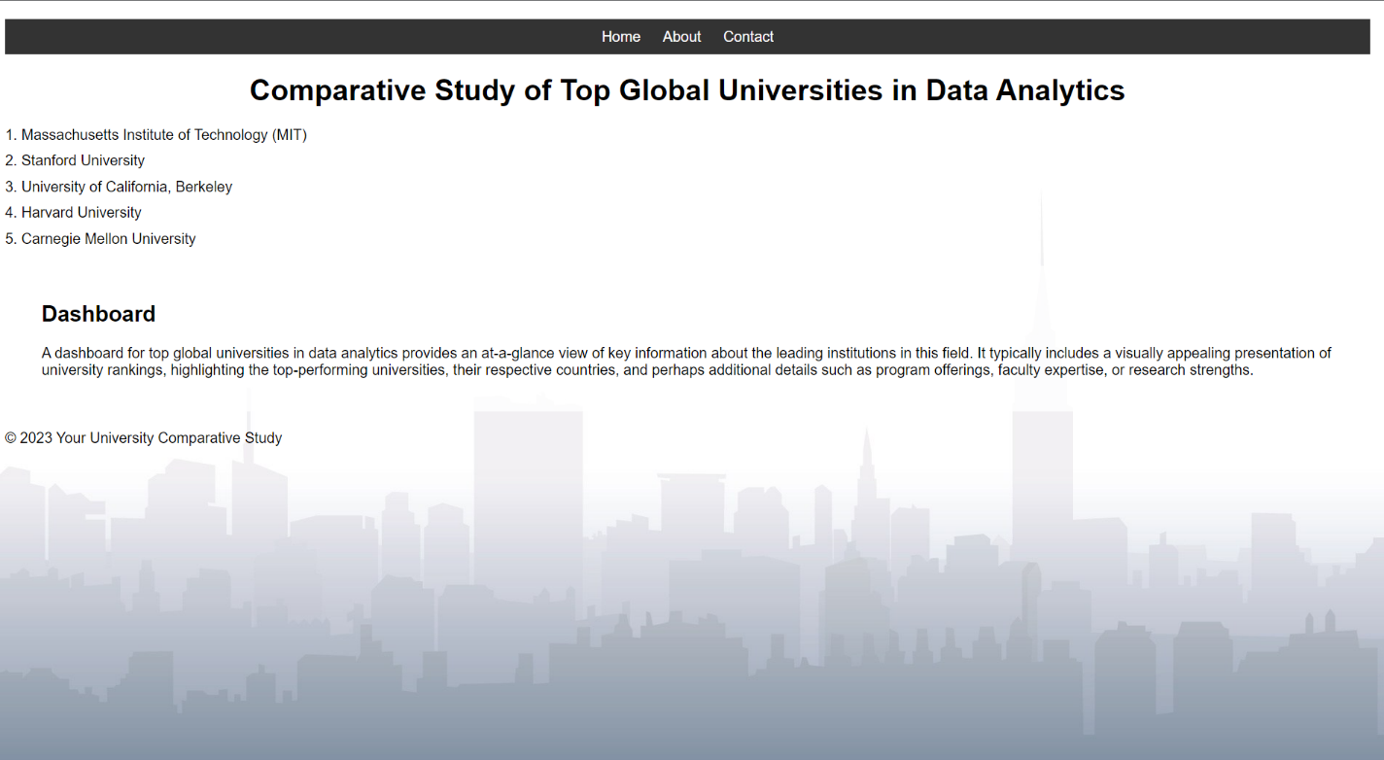

<!DOCTYPE html>

<html>

<head>

<meta charset="UTF-8">

<title>Comparative Study of Top Global Universities in Data Analytics</title>

<style>

body {

background-image: url('bg.jpg'); /* Replace 'background-image.jpg' with your image URL */

background-size: cover;

background-attachment: fixed;

font-family: Arial, sans-serif;

margin: 0;

padding: 0;

}

header {

background-color: rgba(0, 0, 0, 0.7);

color: #fff;

padding: 20px;

text-align: center;

}

nav {

text-align: center;

background-color: #333;

padding: 10px;

}

nav a {

text-decoration: none;

color: #fff;

margin: 10px;

}

.dashboard {

background-color: rgba(255, 255, 255, 0.8);

padding: 20px;

margin: 20px;

border-radius: 5px;

}

/* Add your CSS styles here */

body {

font-family: Arial, sans-serif;

margin: 20px;

}

h1 {

text-align: center;

}

#university-list {

list-style-type: none;

padding: 0;

}

.university {

margin-bottom: 10px;

}

</style>

</head>

<body>

<nav>

<a href="#home">Home</a>

<a href="#about">About</a>

<a href="#contact">Contact</a>

</nav>

<h1>Comparative Study of Top Global Universities in Data Analytics</h1>

<ul id="university-list">

<li class="university">1. Massachusetts Institute of Technology (MIT)</li>

<li class="university">2. Stanford University</li>

<li class="university">3. University of California, Berkeley</li>

<li class="university">4. Harvard University</li>

<li class="university">5. Carnegie Mellon University</li>

<!-- Add more universities as needed -->

</ul>

<div class="dashboard">

<h2>Dashboard</h2>

<!-- Your dashboard content goes here -->

<p>A dashboard for top global universities in data analytics provides an at-a-glance view of key information about the leading institutions in this field. It typically includes a visually appealing presentation of university rankings, highlighting the top-performing universities, their respective countries, and perhaps additional details such as program offerings, faculty expertise, or research strengths.</p>

</div>

<!-- Additional content and sections can be added here -->

<footer>

<p>&copy; 2023 Your University Comparative Study</p>

</footer>

</body>

</html>

GITHUB LINK:

https://github.com/aravinthk1504/Data-Titans-Unearthing-Trends-From-LinkedIn-Influencers/upload/main/Final%20Deliverable

PROJECT DEMO LINK:

https://drive.google.com/file/d/1s6DLy4IhEPSVpqYdO8M5EmH7W9kjEdDJ/view?usp=drive_link